Open my inbox app from the BPA.
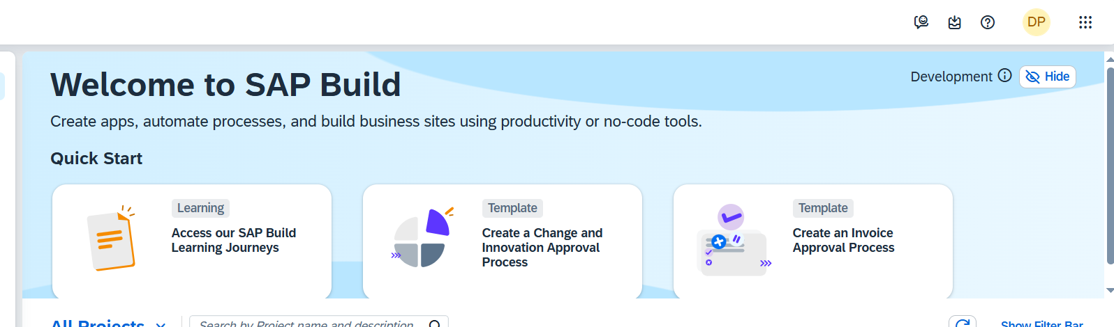
You can see the approval process got trigger with the sap order number you have trigger the API.
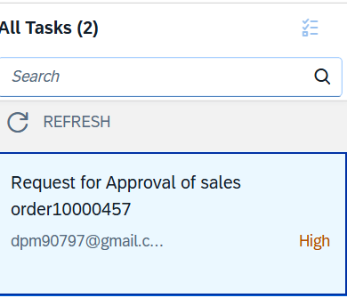
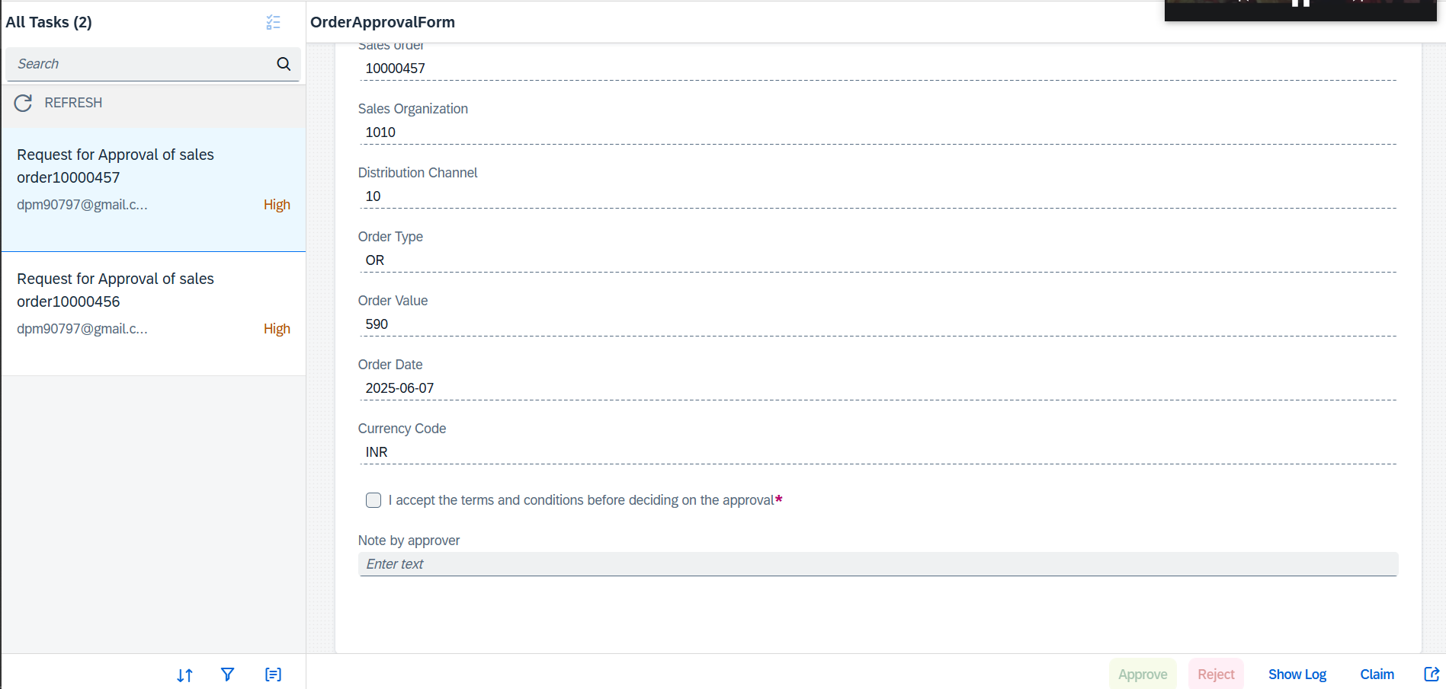

After successfully checking the check box and writing the comment click on the approve button
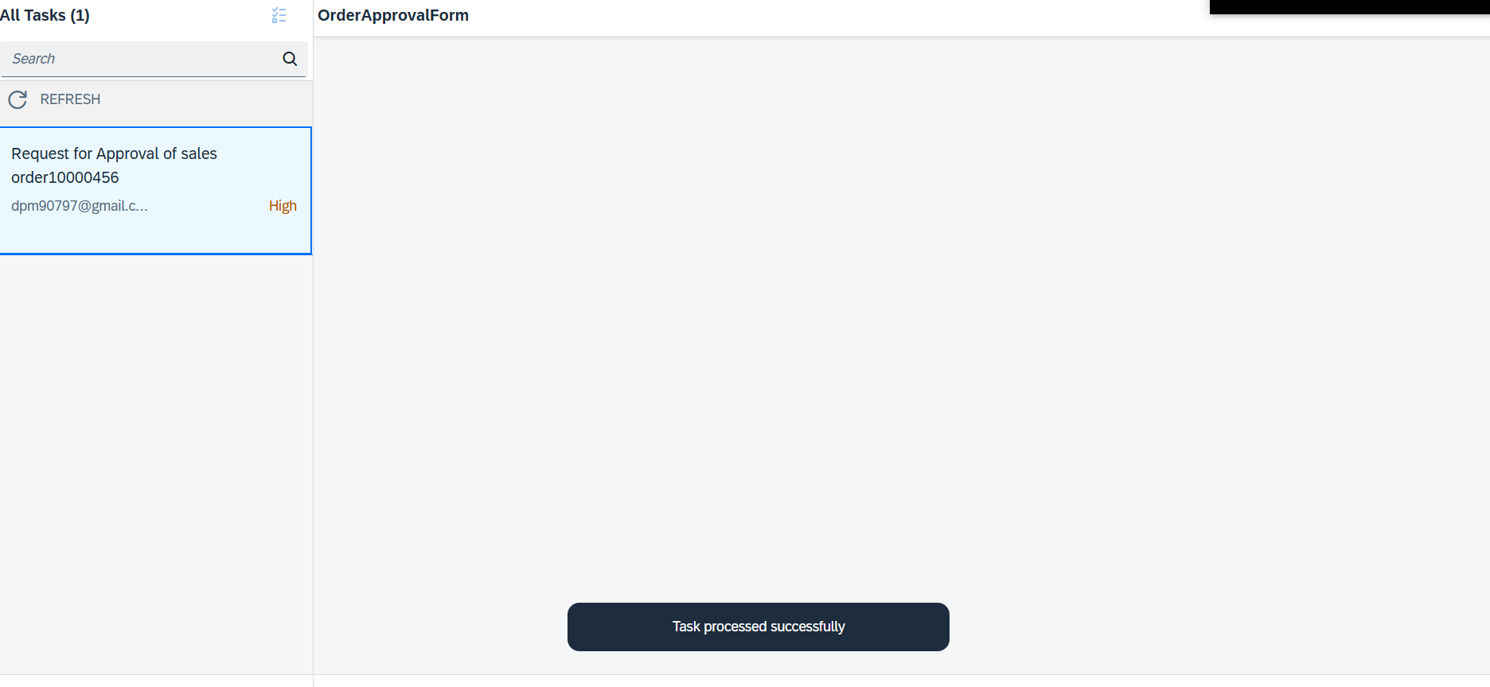

Then it will be moved to other users who has to approve means next level of approval.
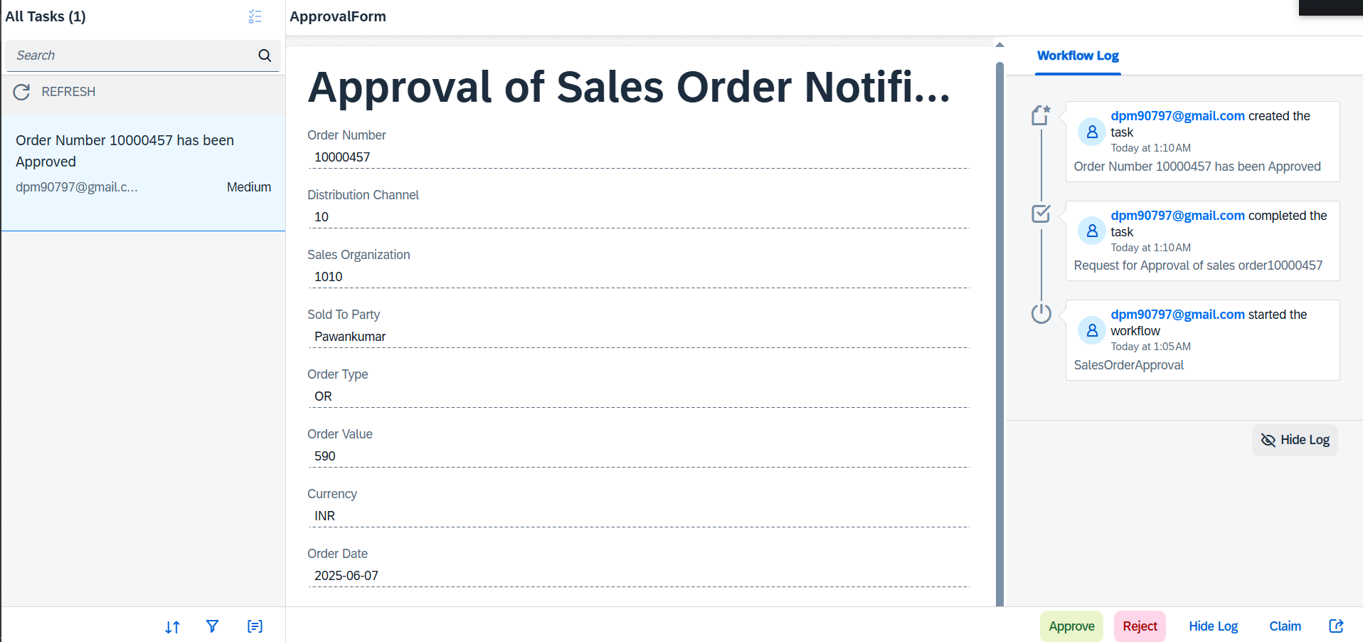

Where as you can reject the sales order.

You can see the all the details of the Workflow in you BPA monitor.
For approved flow.

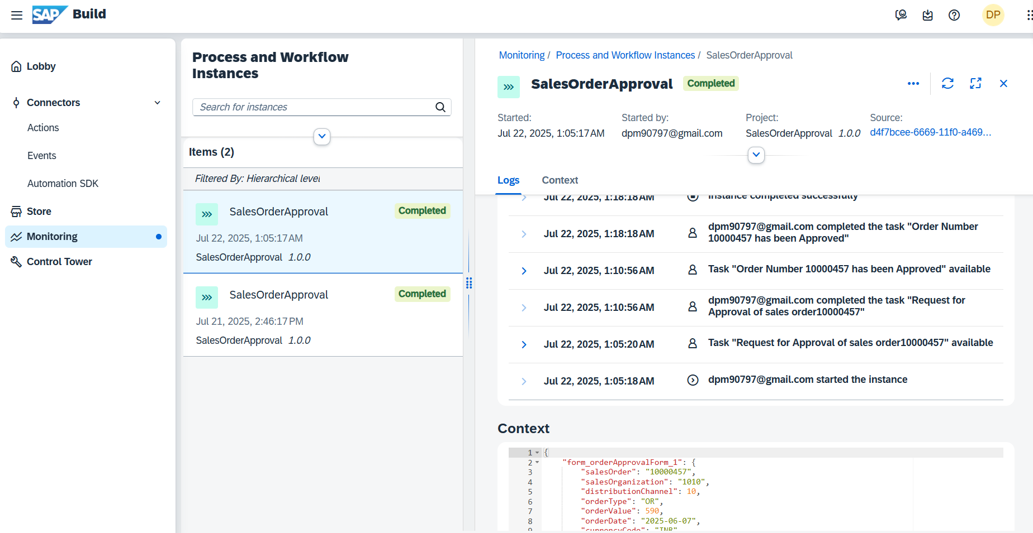

For Rejected Flow
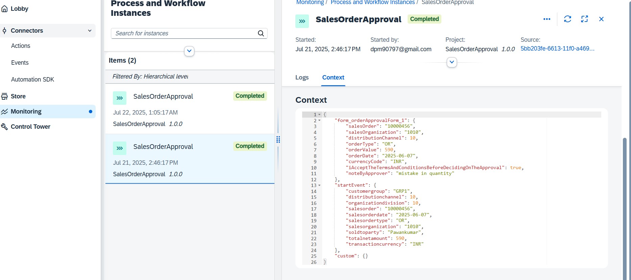

In the mail box check the mail.

For that mail.bpm.send.disabled should not be set to true.

completed

